**18-875/19-739 Homework 4**

**Engineering and Economics of Electric Power Systems**

Due on 02/25/2020 midnight (Canvas submission only) Student Name: Xi Chen

**Key Equation:**

$S_{i}=V_{i}×\sum_{j=1}^{busNum}{{V_{j}}^{*}×{Y_{ij}}^{*}} eq.1$

$P_{cal}=real(S_{i}) eq.2$

$Q_{cal}=imag(S_{i}) eq.3$

$$\left[\begin{matrix}P_{k+1} \\ Q_{k+1}\end{matrix}\right]-\left[\begin{matrix}P_{L} \\ Q_{L}\end{matrix}\right]-\left[\begin{matrix}P_{cal.k+1} \\ Q_{cal.k+1}\end{matrix}\right]=\left[\begin{matrix}∆P \\ ∆Q\end{matrix}\right] eq. 4$$

$$J_{1}=\frac{∂P}{∂θ} J_{2}=\frac{∂P}{∂\left|V\right|} J_{3}=\frac{∂Q}{∂θ} J_{4}=\frac{∂Q}{∂\left|V\right|}$$

$\left[\begin{matrix}J_{1} & J_{2} \\ J_{3} & J_{4}\end{matrix}\right]×\left[\begin{matrix}∆θ_{k} \\ ∆{\left|V\right|}_{k}\end{matrix}\right]=\left[\begin{matrix}∆P \\ ∆Q\end{matrix}\right]$**eq.5**

${P,Q,V,Θ}^{k+1}={P,Q,V,Θ}^{k}+∆{P,∆Q,∆V,∆Θ}_{k}$**eq.6**

Since the voltage and angle of the slack bus are constant so I set my lower bounds and upper bounds 0. Also, the voltage of the PV bus also constant, so I set the lower and upper bound of the voltage to zero.

$LB=\left[\begin{matrix}{P_{G}}^{ min}-P^{k+1} \\ {Q_{G}}^{min}-Q^{k+1} \\ \begin{matrix}-\frac{π}{2}-θ^{k+1} \\ {|V|}^{min}-{|V|}^{k+1}\end{matrix}\end{matrix}\right]$ $UB=\left[\begin{matrix}{P_{G}}^{ max}-P^{k+1} \\ {Q_{G}}^{max}-Q^{k+1} \\ \begin{matrix}+\frac{π}{2}-θ^{k+1} \\ {|V|}^{max}-{|V|}^{k+1}\end{matrix}\end{matrix}\right]$

**Code Algorithm:**

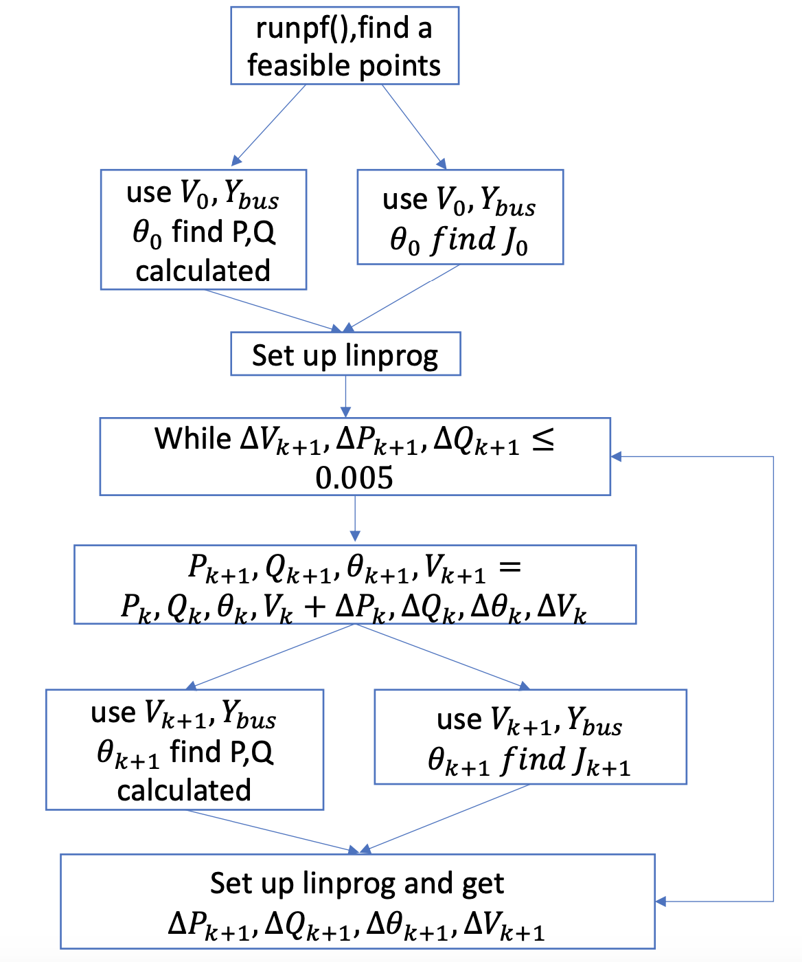

**Main Idea**

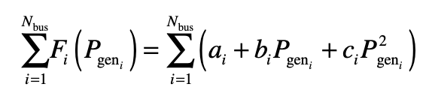

Given a quadratic cost function, we can turn it into linear function by using

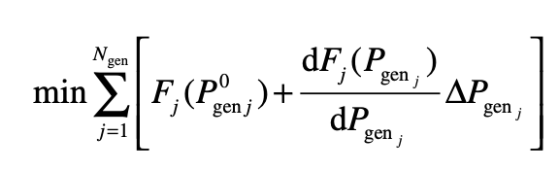

Since 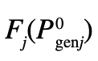 is constant, we can ignore it in the objective function. So, the quadratic function is now in a linear form.

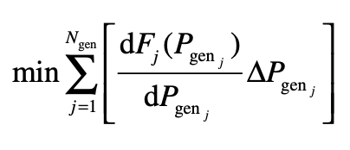

Which 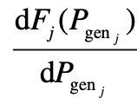 is evaluated at Pgenj

Now, our objective function is related to the $∆P.$ Next, we will turn $P,Q,V,Θ into ∆{P,∆Q,∆V,∆Θ}_{k}$**.**

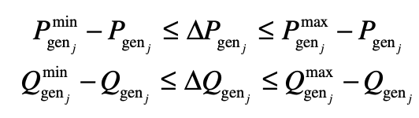

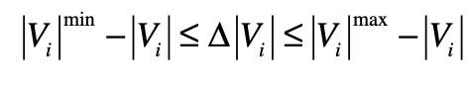

By doing that, each variable will be linear now.

**Result**

I cannot remember how many days I have devoted to this homework and I learn a lot from it, especially I get a deeper understanding of how the jacobian works and how to code the Ybus and nodal power flow equation which I have never done before. I also have learned how to manipulate the matrix in MATPOWER. However, I didn’t get a feasible result because my code gets into an infinite loop after the first iteration and I cannot find a way to solve it. After the first iteration, my generation 1 in case9 will drop to 0.1 pu which is the minimum output. It cannot be that small. I guess there may be something wrong with my jacobian but I cannot figure out where is wrong. Since it is close to 11:59 now so I decided to submit.